Question1) Find the maximum torque, that can be applied safely to a shaft of 300mm diameter. The permissible angle of twist is 1.5 degree in a length of 7.5 m and the shearing stress is not to exceed 42 N/mm². Take G = 84.4kN/mm²
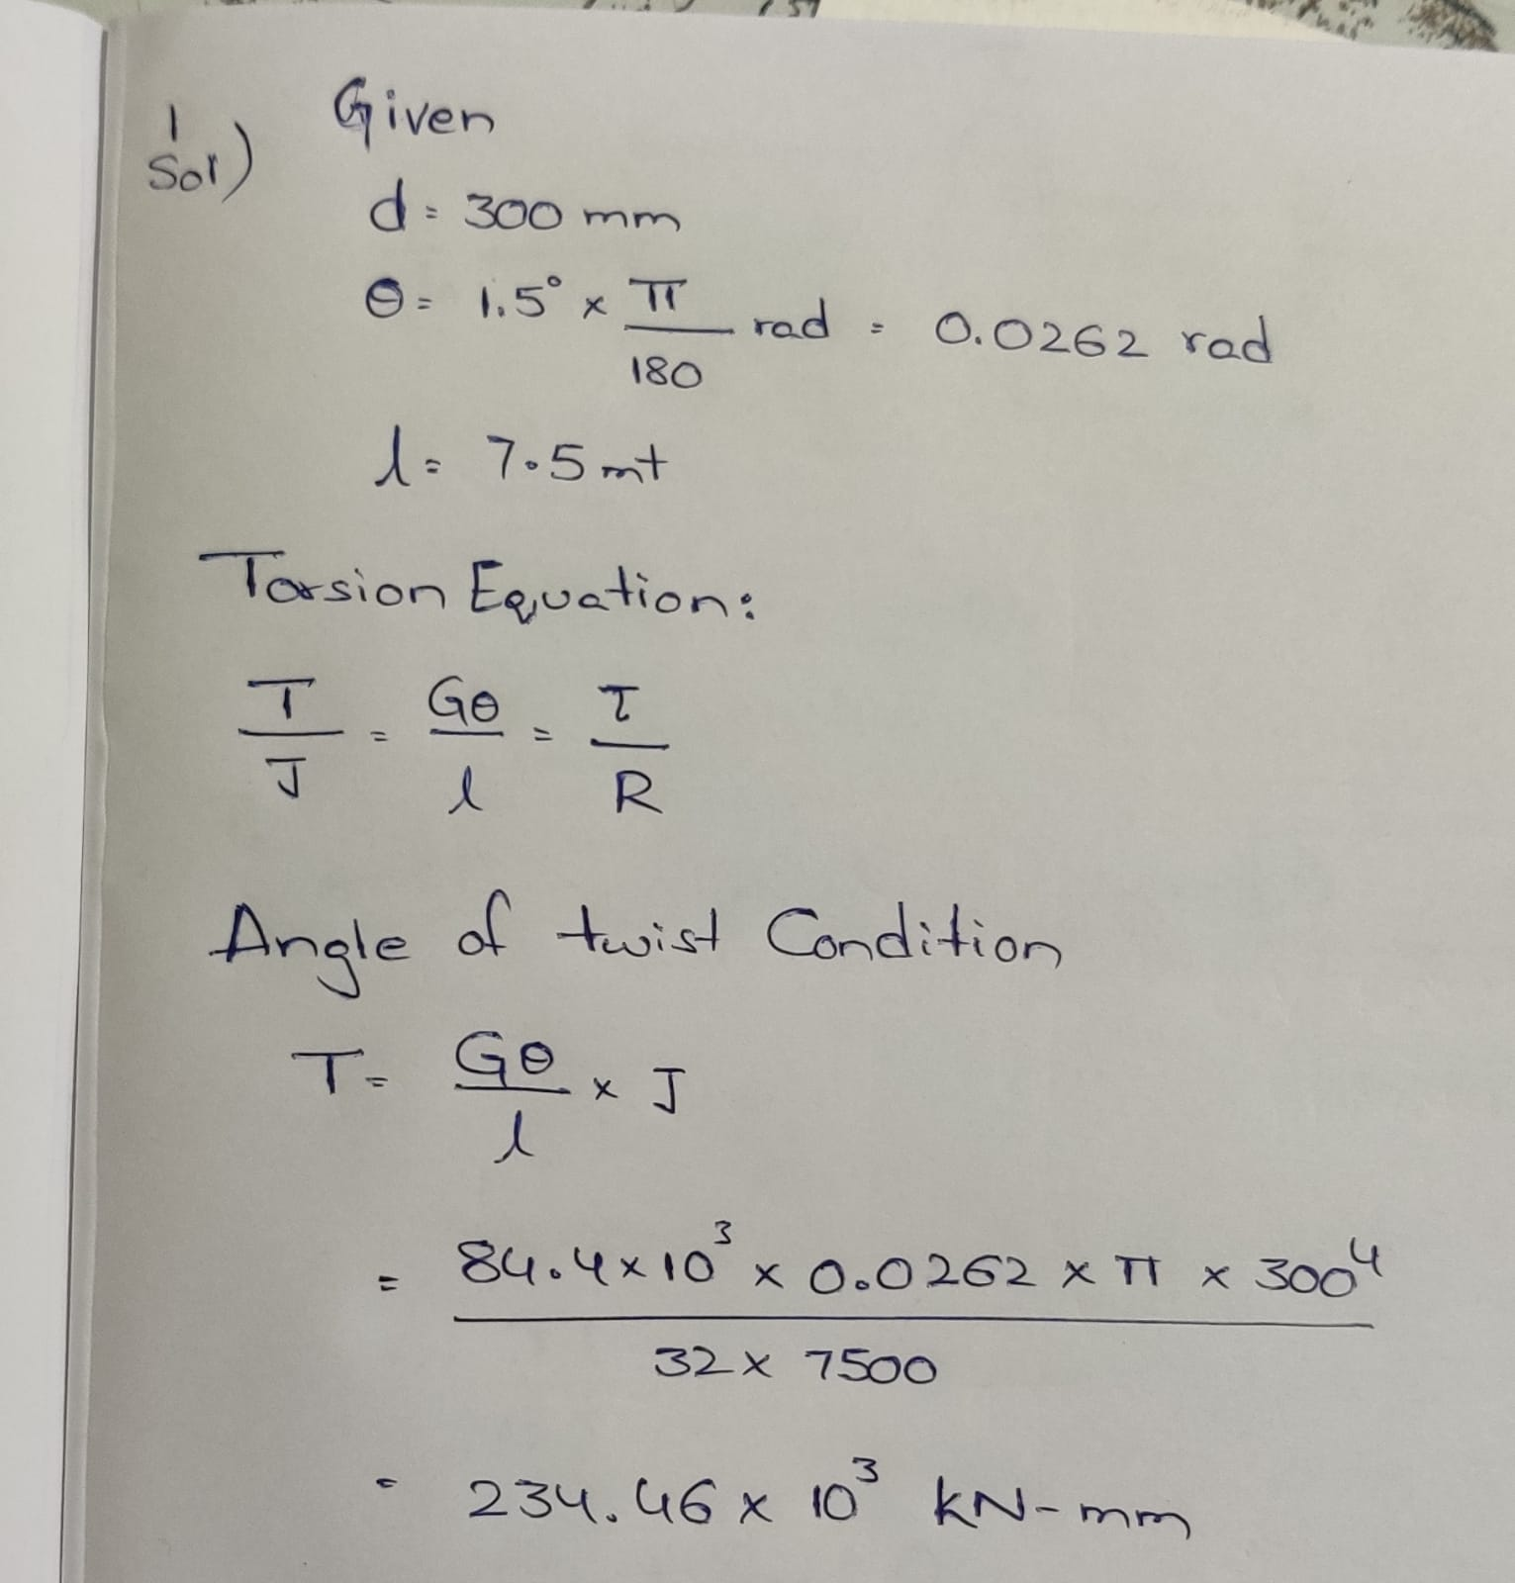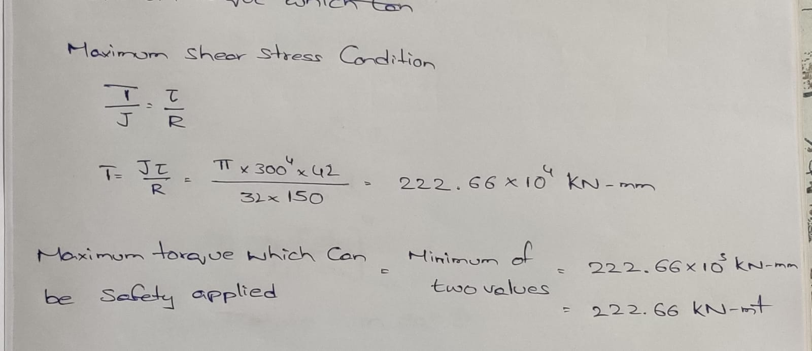
Question2) Two circular shafts AB and BC of the same material but different diameter are welded together at point B as shown in the figure. Ends A and C are fixed. An external torque T_{o} is applied to the shafts at point B. Find the torques exerted on the ends of the shafts at A and C.
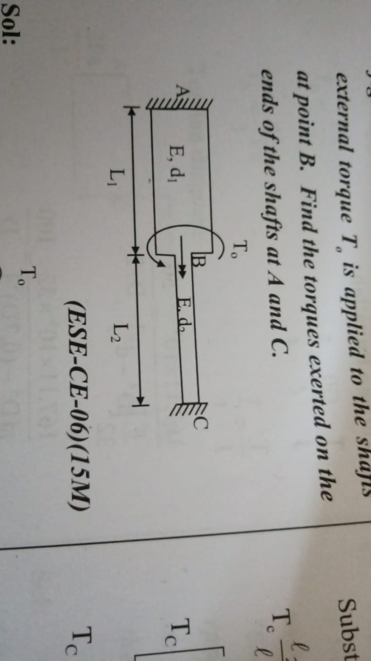
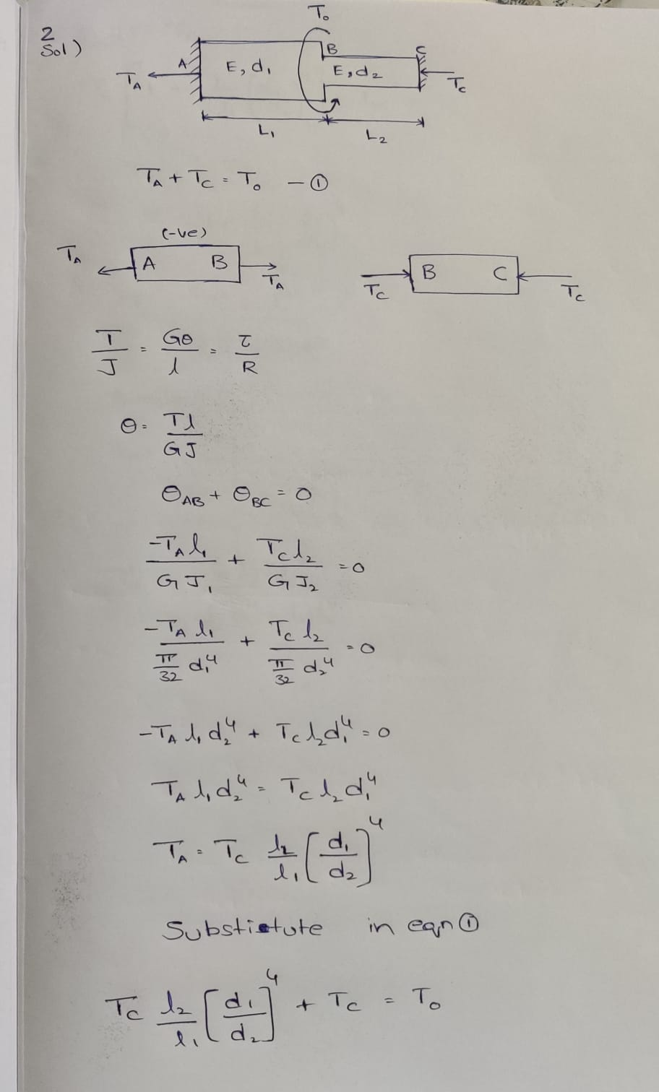
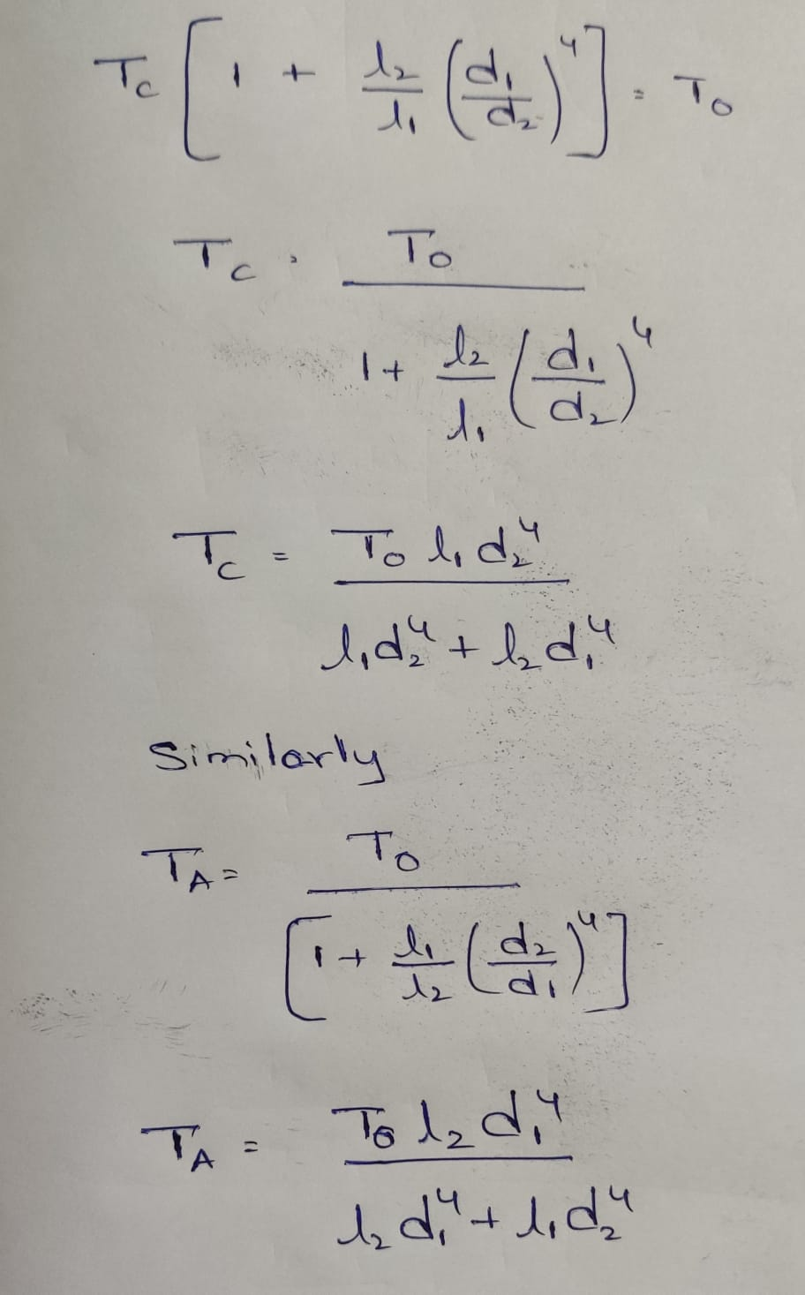
Ques 3: Two shafts AB and BC of the same material but different diameter are welded together at point B. Ends A and C are fastened securely so that the shafts cannot rotate at these points. An external twisting couple M_{o} is applied to the shafts at point B. Find the twisting couples exerted on the ends of the shafts at A and C.
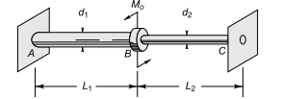
Solution3:
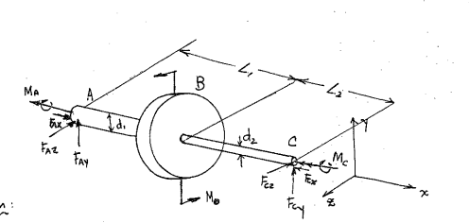
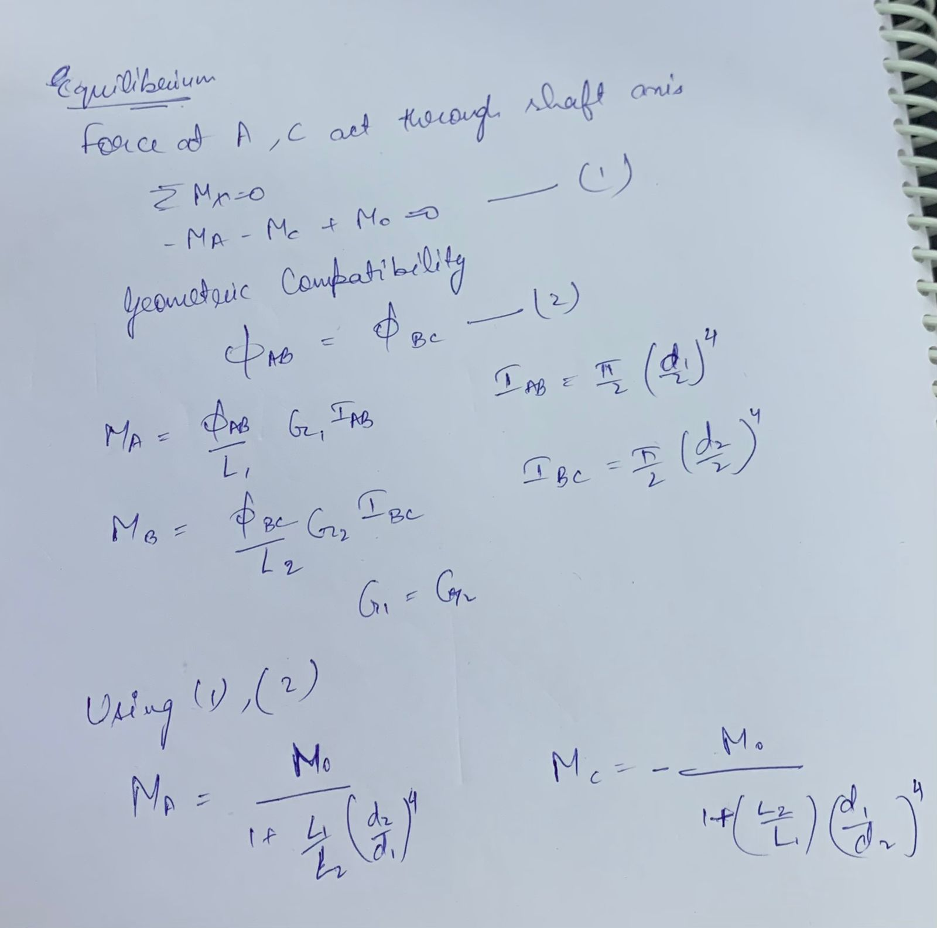

Question 4: Two shafts A and B of same material and of the same lengths are subjected to the same torque. Shaft A is a solid circular section, while shaft B is a hollow circular section whose internal diameter is 0.7 times its outside diameter. If the maximum shear stress each shaft is to be the same, compare the weights of the two shafts.
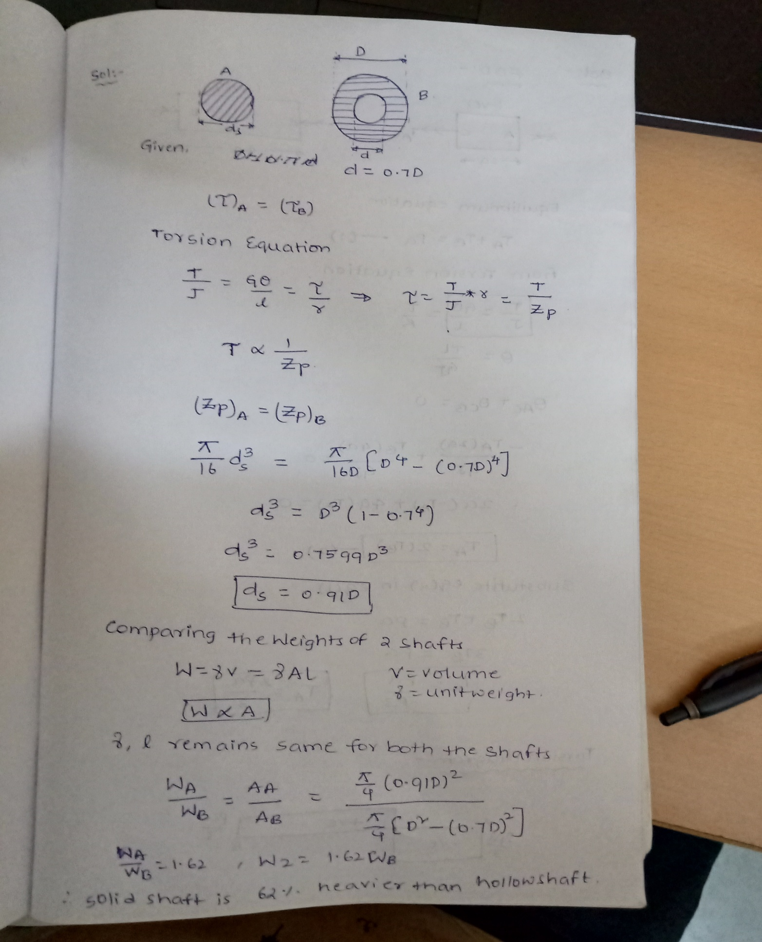
Question 5: A horizontal beam of length ‘6a’ has built in ends. The beam has two horizontal projecting cantilevers of length ‘a’ at one third points which carry vertical loads of magnitudes ‘P’ and ‘2P’ one at each end. Draw torsion diagram.
